- Bluebook Page52 May 2019 Variant Five examination:

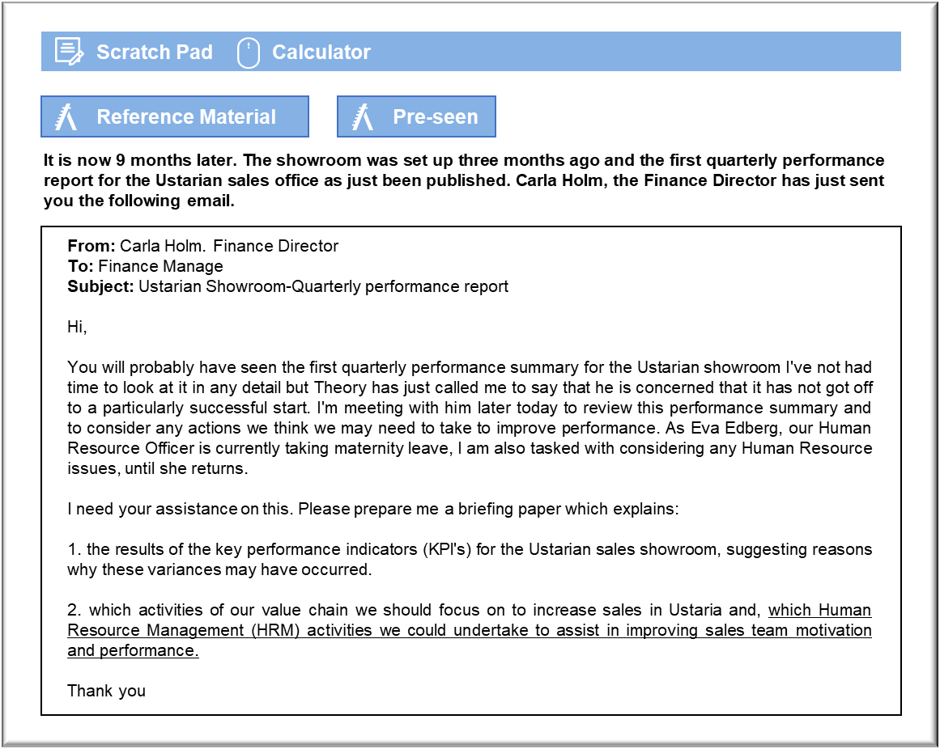

MANAGEMENT CASE STUDY MAY 2019 EXAM ANSWERS

Variant5 Task4
These answers have been provided by CIMA for information purposes only. The answers created are indicative of a response that could be given by a good candidate. They are not to be considered exhaustive, and other appropriate relevant responses would receive credit.

CIMA will not accept challenges to these answers on the basis of academic judgement.

Evaluation of first quarter performance report of the Ustarian showroom
To some extent, I can understand why Theo has concerns about the performance of the
Ustarian showroom after its first quarter of activity. However, there may be some
reasoning behind these results. Whilst having the equivalent Corvola showroom
figures may offer some insight as to the targets that the Ustarian showroom could be
aiming for in the future, it is unrealistic to expect a new showroom to be performing at
the levels of a well-established one, especially given the fact that it is in a completely
different country.
There appears to be some significant variances on the expected number of sales
enquiries, both in the showroom and online. Both measures are almost 50% below
expected levels. Before we make any judgement on this it would be useful to know on
what these targets were based. If they are based on the Corvolan showroom and
website enquiries then this may not be the best target level. The Corvolan showroom
and website are well established and therefore it will take time for such target levels to
be achieved.
In terms of house sales agreed, the variance of 1 is not significant. When we compare
house sales signed to the number of enquiries (i.e. a sales conversion rate), in fact the
showroom staff appear to be doing well. Two house sales signed based on 38 customer
enquiries is a conversion rate of 5%. This can be compared to a target conversion rate
of 4%. Therefore, the sales staff are in fact doing well based on the enquiries they have
received. However, compared to Corvola, these are both very low, as the Corvolan
showroom has a target sales conversion rate of 20%. Again, we should not be over
harsh in judging the Ustarian sales team as the Corvolan sales team have significantly
more experience, hence the target is higher. However, the Ustarian sales team have
certainly performed well in terms of sales price agreed, with a positive variance of
C$0.2 million. This is indeed very encouraging as it suggests that the customers in
Ustaria are willing to pay a premium price for a Jord home which could have a very
positive impact on our revenues.
Customer satisfaction ratings are lower than we would have hoped, particularly as we
have built our competitive advantage on high levels of customer service and customer
satisfaction. Again, it is early days and we need to assess why out customer ratings are
lower than expected. This indicator may indeed be related to the staff satisfaction
rating which is also lower than expected. If staff are not happy with either conditions of
work or pay, this may lead to a potential knock on effect on our customers. Again, this
could also be linked to both the staff absentee indicator and the days training indicator
both of which indicate worse than expected performance. If staff are receiving less
training than expected this may impact on morale and levels of performance, thus
impacting on customer satisfaction. The staff satisfaction result may also be causing
the increased days of staff absence. Therefore, I think that our primary area of concern
is to look at how we are training and managing the Ustarian sales staff in order to
optimise their satisfaction and performance.
May 2019 9 CIMA Gateway Case Study Exam

Improvements in the value chain
The first area of the value chain we could address is operations, as we can see that
target conversion rate is only 4%, compared to a target conversion rate of 20% for the
Corvola showroom. Improvements to the products that we are offering or the lead
times on the houses may in fact increase this conversion rate, if we can identify if it is
these issues which are causing them not to order a Jord house. A further area of the
value chain that we could address is our marketing and sales activities, (within the
primary activities of our value chain). It would appear from the performance indicators
that we are not reaching the targeted levels of sales enquiries expected and therefore
we must look at how we are marketing and advertising our homes in the Ustarian
market. We need to consider if our showroom is using the correct means of
advertising, and in particular whether our website is appropriately targeted and
advertised. We may need to consider improving our internet search profile to try to
gain more customer awareness. We need to consider how our Ustarian sales staff are
handling sales enquiries and if they are responding to these effectively.
In terms of the secondary activities in our value chain, we could consider enhancing
the technological support we offer to the Ustarian showroom. This may mean giving
them electronic real-time access to production schedules and architectural and design
models in order to communicate effectively with potential customers. We must have
excellent technological communication facilities which allow the Ustarian showroom
staff immediate and uninterrupted connection with Head Office. Poor technological
support could have serious implications on our conversion rate.
A further secondary activity which we need to focus on to improve the performance of
the Ustarian showroom is human resource management which will entail the selection,
retention and promotion of staff, the appraisal of staff and implementation of
performance rewards.
From our analysis of the quarterly performance of report of the Ustarian showroom, it
would appear that staff motivation may be an issue. Therefore, there are a number of
specific HRM activities we could implement to improve staff motivation.
1. Clearly training levels did not meet expected targets and therefore appropriate
job- related training must be carried out. It may be useful to ask Corvolan sales
staff to carry this out at the Ustarian showroom, face-to-face, to explain all of
the technical and product knowledge and to deliver sales technique training,
which will be specific to our products. If the sales team feel confident about the
products they are selling, they will be more motivated.
2. Provide sales staff with the opportunity to feedback to the Corvolan head office
with any concerns and queries. The sales staff must not feel isolated as this will
lead to demotivation
3. Implement a staff sales bonus system. Staff should be rewarded for hitting sales
targets, based on either number of houses sold per month or the revenue
May 2019 10 CIMA Gateway Case Study Exam
generated per month. However, we will need to carefully manage this activity as
we do not want to cause dysfunctional behaviour.
4. Regular staff appraisals on performance so that sales staff can understand their
performance in the overall organisation context and can also have a forum to
air their own concerns at management level.

